# Requirements – Student #4

Please, fill in the following form, save this document, and attach it to every deliverable. Attaching this document entails that you are the author of the work delivered, you have not cheated in any way, and you have read and understood the information delivered regarding the subject, with a special emphasis on the methodological guidelines and how your work is going to be graded. Make sure that your project works well with the latest version of the development framework.

|  |
| --- |
| **Group:** C2.X02 |
| **Repository:** https://github.com/SoniaRM/Acme-SF-D04-24.5.0 |
| **Student #4**  **ID Number:** 53966183H  **UVUS:**  josmirmar2  **Name:**  Miret Martín, José Manuel  **Roles:**  desarrollador, tester, project manager |
| **Date:** Tomares Febrero 5, 2024 |

# MANDATORY Deliverable D01: introduction

## Information requirements

Intentionally blank.

## Functional requirements

1. Modify the anonymous menu so that it shows an option that takes the browser to the home page of your favourite web site. The title must read as follows: “〈id-number〉: 〈surname〉, 〈name〉”, where “〈id-number〉” denotes your DNI, NIE, or passport number, “〈surname〉” denotes your surname/s, and “〈name〉” denotes your name/s.

x

## Non-functional requirements

Intentionally blank.

## Testing requirements

Intentionally blank.

## Managerial requirements

Intentionally blank.

# MANDATORY Deliverable D02: data models

## Information requirements

1. The **sponsorships** are related to a **project** with the aim of achieving greater visibility in the market. The system must store the following data about them: a **code** (pattern “[A-Z]{1,3}-[0-9]{3}”, not blank, unique), a **moment** (in the past), a **duration** (after the moment, at least one month long), an **amount** (positive), a **type** of sponsorship (“Financial”, “In kind”), an **optional** **contact** email, and an **optional link** with further information.

X

1. Each **sponsorship** is billed through the use of **invoices**.The system must store the following data about them: a **code** (pattern “IN-[0-9]{4}-[0-9]{4}”, not blank, unique), a **registration time** (in the past), a **due date** (at least one month ahead the registration time), a **quantity** (positive not nought), the **tax** that it is applied (positive or nought), the **total** **amount** (calculated by adding together the **quantity** and the **tax applied**), and an **optional link** with further information.

X

1. The system must handle **sponsor** dashboards with the following data: total number of **invoices** with a **tax** less than or equal to 21.00%; total number of **sponsorships** with a **link**; average, deviation, minimum, and maximum **amount** of the **sponsorships**; average, deviation, minimum, and maximum **quantity** of the **invoices**.

X

## Functional requirements

Intentionally blank.

## Non-functional requirements

Intentionally blank.

## Testing requirements

1. Produce assorted sample data to test your application informally. The data must include two **sponsor** accounts with credentials “**sponsor1/ sponsor1**” and “**sponsor2/ sponsor2**”.

X  Falta dejar vacíos los atributos opcionales en los datos de prueba

## Managerial requirements

Intentionally blank.

# MANDATORY Deliverable D03: implementing features

## Information requirements

Intentionally blank.

## Functional requirements

1. Operations by **sponsors** on **sponsorships:**

* List the **sponsorships** that they have created.
* Show the details of their **sponsorships**.
* Create, update, or delete their **sponsorships**. **Sponsorships** can be updated or deleted as long as they have not been published. For a **sponsorship** to be published, the sum of the **total amount** of all their **invoices** must be equal to the **amount** of the sponsorship.

Se puede patrocinar proyectos que aún no están publicados. Los proyectos que no están publicados, solo pueden ser vistos/editados por sus managers propietarios. En la siguiente vista se muestran tres proyectos pero solo el PRJ-0002 está publicado.

En la siguiente captura se puede observar que solo el PRJ-0002 está publicado:

Este problema ya se presentaba en la convocatoria anterior.

El momento del patrocinio, se refiere al momento de creación y eso es un dato que configura el sistema, no un usuario final, que puede indicar cualquier fecha no siendo ésta la realidad. El momento es la fecha en la que se crea el patrocinio

No puedo configurar la cantidad del patrocinio, ¿por qué? es un dato que el usuario final debería de poder introducir

Con los siguientes datos, ni se crea el patrocinio, ni se muestran mensajes de error:

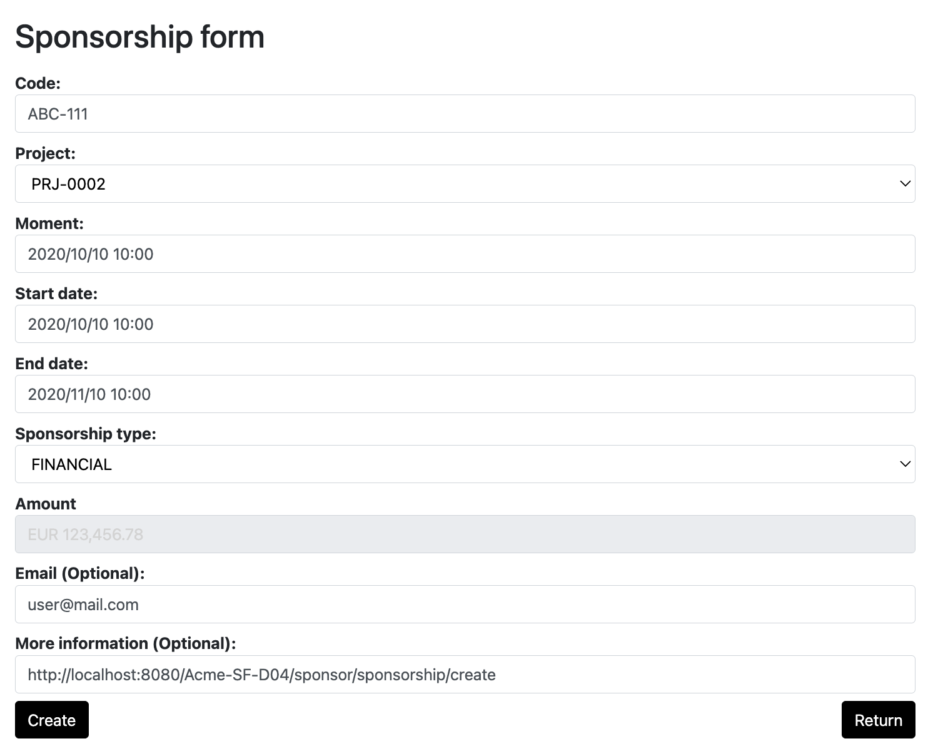

A veces sale el mensaje siguiente:

y otras veces no. No sé si depende de que anteriormente el usuario estaba creado o que el proyecto ya estaba en la base de datos o recién creado, pero no funciona en todos los casos.

De la misma forma, en algunos casos puedo publicar un patrocinio sin invoices y otras veces muestra el mensaje de error.

He publicado el proyecto anterior y no tiene ninguna invoice porque aún no he creado ninguna invoice en el sistema. Eso se puede ver porque el atributo amount está a 0, lo que significa que no se ha actualizado con las cantidades de ninguna invoice.

1. Operations by **sponsors** on **invoices**:

* List the **invoices** in their **sponsorships**.
* Show the details of their **invoices**.
* Create and publish an **invoice**.
* Update or delete an **invoice** as long as it is not published.

También se permite modificar el momento por el usuario cuando eso es un dato que configura el sistema.

Muestra algunos errores, pero no queda claro qué hay que hacer. Por ejemplo, en el due date se indica que no es correcto, pero no indica por qué.

No deja persistir la invoice justo en la fecha del sistema (aunque en el error de validación se indica que se puede indicar una fecha en el pasado o en el presente.

Esto no está implementado como se pide. Si a la hora de publicar una invoice, la cantidad fuera superior a la del patrocinio, debería de mostrarse un error de validación, pero como no está implementado como se pide, siempre lo permite.

1. Operations by **sponsors** on **sponsor** dashboards:

* Show their **sponsor** dashboards.

X

## Non-functional requirements

Intentionally blank.

## Testing requirements

Intentionally blank.

## Managerial requirements

Intentionally blank.

# MANDATORY Deliverable D04: formal testing

## Information requirements

Intentionally blank.

## Functional requirements

Intentionally blank.

## Non-functional requirements

Intentionally blank.

## Testing requirements

1. Produce a test suite for Requirements #6 and #7.

Faltan pruebas para detectar los errores que he comentado anteriormente. Sobre todo, uno fácil de detectar podría ser el de las fechas. La fecha del sistema debería de ser aceptada en los sponsorships.

## Managerial requirements

1. Produce a testing report.

X La conclusión no se hace explícita. No se indica si hay evidencia estadística para determinar que el rendimiento de un ordenador sea mejor que otro. Se indica que las medias son comparables y, si son comparables, ¿cuál es la conclusión?

# SUPPLEMENTARY Deliverable D01: introduction

## Information requirements

Intentionally blank.

## Functional requirements

Intentionally blank.

## Non-functional requirements

Intentionally blank.

## Testing requirements

Intentionally blank.

## Managerial requirements

1. Produce an analysis report.

1. Produce a planning and progress report.

# SUPPLEMENTARY Deliverable D02: data models

## Information requirements

1. There is a new project-specific role called **sponsor**, which has the following profile data: **name** (not blank, shorter than 76 characters), a list of expected **benefits** (not blank, shorter than 101 characters), an **optional web page** with further information, and an **optional email contact**.

## Functional requirements

Intentionally blank.

## Non-functional requirements

Intentionally blank.

## Testing requirements

Intentionally blank.

## Managerial requirements

1. Produce a UML domain model.

1. Produce an analysis report.

1. Produce a planning and progress report.

# SUPPLEMENTARY Deliverable D03: implementing features

## Information requirements

Intentionally blank.

## Functional requirements

1. Operations by anonymous principals on user accounts:

* Sign up to the system and become a **sponsor**.

1. Operations by **sponsors** on user accounts:

* Update their profiles.

1. Operations by any principals on **sponsorships**:

* List the **sponsorships** in the system that are published.
* Show the details of the **sponsorships** that they can list (excluding their **invoices**).

## Non-functional requirements

Intentionally blank.

## Testing requirements

Intentionally blank.

## Managerial requirements

1. Produce an analysis report.

1. Produce a planning and progress report.

1. Produce a lint report.

# SUPPLEMENTARY Deliverable D04: formal testing

## Information requirements

Intentionally blank.

## Functional requirements

Intentionally blank.

## Non-functional requirements

Intentionally blank.

## Testing requirements

Intentionally blank.

## Managerial requirements

1. Produce an analysis report.

1. Produce a planning and progress report.